Practical No: 01

**Aim:** Displaying different Led Patterns with Raspberry Pi.

**Hardware Required:**

1. Raspberry Pi 3B+
2. Ethernet Cable
3. Monitor
4. HDMI to VGA convertor
5. Micro SD card (any class best is class 10)
6. Adaptor with 5v 2A
7. USB mouse
8. USB keyboard
9. 3 LED
10. Breadboard
11. Wires

**Software Required:**

1. Raspbian OS

**Procedure:**

1. **Hardware Setup**

* 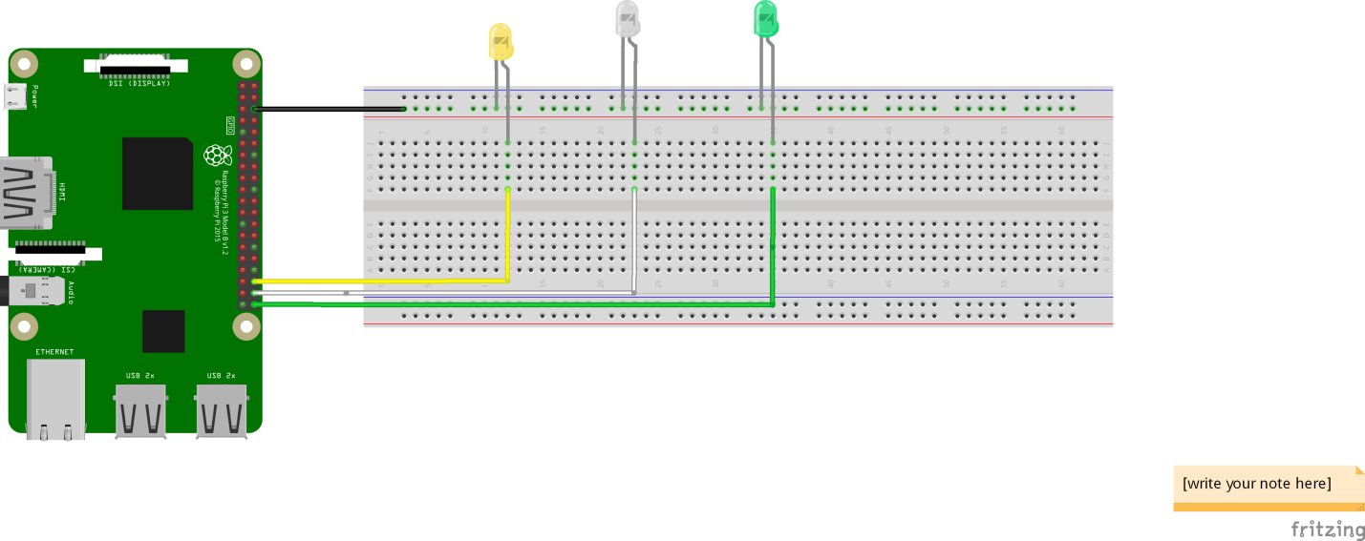Connect components as in the Diagram

GPIO16 🡪 LED1 Anode

GPIO20 🡪 LED2 Anode

GPIO21 🡪 LED3 Anode

*Black wire is the GND (ground)

1. **Software Setup**

* Geany Programmer’s Editor
* Rapberry 🡺Programming 🡺 Geany Programmer’s Editor

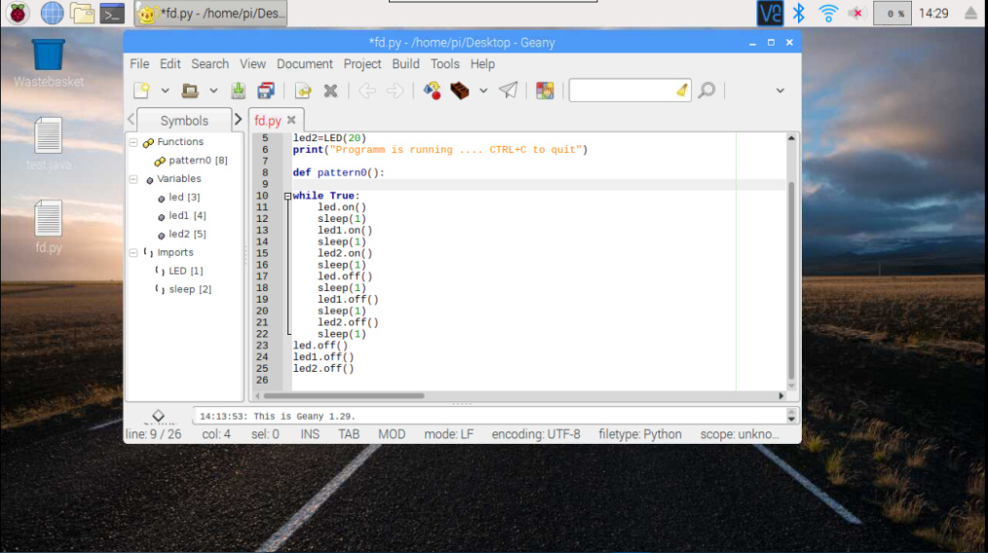

* File 🡺 New
* File 🡺 Save (provide file name anything) *.py
* Type The Following Code

*from gpiozero import LED*

*from time import sleep*

*led1=LED(21)*

*led2=LED(16)*

*led3=LED(20)*

*led4=LED(26)*

*print("Program is running .... CTRL+C to quit")*

*def pattern1():*

*print("Pattern 1 running...")*

*led1.on()*

*sleep(0.5)*

*led1.off()*

*sleep(0.5)*

*led2.on()*

*sleep(0.5)*

*led2.off()*

*sleep(0.5)*

*led3.on()*

*sleep(0.5)*

*led3.off()*

*sleep(0.5)*

*led4.on()*

*sleep(0.5)*

*led4.off()*

*sleep(0.5)*

*def pattern2():*

*print("Pattern 2 running ....")*

*led1.on()*

*led2.on()*

*led3.on()*

*led4.on()*

*sleep(1)*

*led1.off()*

*led2.off()*

*led3.off()*

*led4.off()*

*sleep(1)*

*def pattern3():*

*print("Pattern 3 running ....")*

*for i in range(4):*

*if i==1:*

*for i in range(3):*

*led1.on()*

*sleep(0.1)*

*led1.off()*

*sleep(0.1)*

*elif i==2:*

*for i in range(3):*

*led2.on()*

*sleep(0.1)*

*led2.off()*

*sleep(0.1)*

*elif i==3:*

*for i in range(3):*

*led3.on()*

*sleep(0.1)*

*led3.off()*

*sleep(0.1)*

*else:*

*for i in range(3):*

*led4.on()*

*sleep(0.1)*

*led4.off()*

*sleep(0.1)*

*def pattern4():*

*print("Pattern 4 running ....")*

*led1.on()*

*sleep(1)*

*led1.off()*

*sleep(1)*

*led2.on()*

*sleep(1)*

*led2.off()*

*sleep(1)*

*led3.on()*

*sleep(1)*

*led3.off()*

*sleep(1)*

*led4.on()*

*sleep(1)*

*led4.off()*

*sleep(1)*

*while True:*

*pattern1()*

*for i in range(2):*

*pattern2()*

*pattern3()*

*pattern4()*

*led1.off()*

*led2.off()*

*led3.off()*

*led4.off()*

**Conclusion:**

1. In this practical we have learned how to connect GPIO pins to LEDs.
2. We have learned about “gpiozero” and “time” module of Python. 